Apple Monsters
Time: 20 minutes | Serves: 6
Gluten Free / Dairy Free / Vegetarian
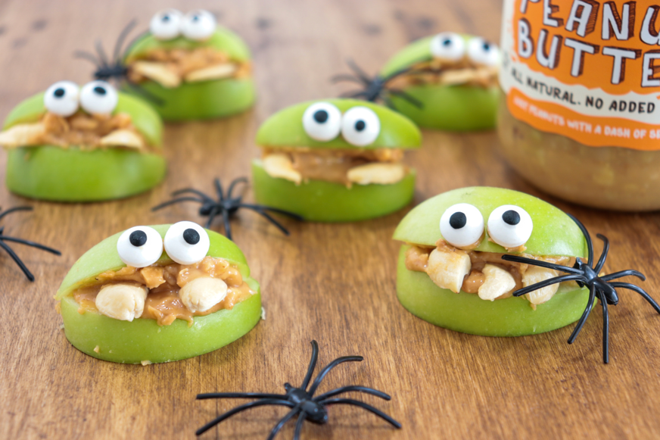

Ingredients

1 green apple
Mayver’s Extra Crunchy Peanut Butter (Link: https://mayvers.com.au/product/extra-crunchy-peanut-butter/)
6 cashew nuts
Candy eyes (for decoration)

Method
- Slice apple into 12 wedges (6 pairs), and split cashew nuts in half, lengthways.
- Spread Mayver’s peanut butter on bottom wedges of each pair and arrange split cashew nuts on top to look like fangs. Spread peanut butter on top wedge and place onto bottom wedge to look like a mouth.
- Use a very small amount of peanut butter to stick candy eyes onto top wedge.

This recipe was provided by @nataliemewing (Link: https://www.instagram.com/nataliemewing/)

